3. Quantifying a component of fitness in the plants.

Fitness is the ability to survive and reproduce and as such it’s difficult to measure comprehensively. Generally, people measure traits that are correlated with survival and reproduction. For plants, size is a good predictor of the ability to survive and reproduce. There are many ways to measure size; for this project, you’ll measure total leaf area.

- Using the sheet with a mm scale on it (at the end of this handout), write your group name, treatment and type of plant that you have on the paper in such a way that the leaves from each plant (which you will pull off of the plant) are in a group and set apart from the groups of leaves of each of the other plants (see below).
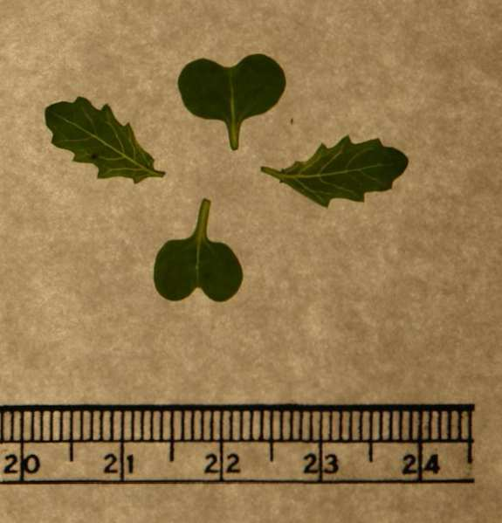
- Carefully, photograph your paper with leaves. Take a shot of the entire collection of leaves, labels and scale. Save it to your computer.
- Open ImageJ and access the image with your picture of leaves on it.
- Set the scale. To do this, click on the Straight line selections tool (the straight line button, fifth from the left). Trace along your ruler for a few centimeters then select Set Scale under the Analyze menu. Then put in the distance in millimeters in the Known Distance field, and the unit (mm) in the Unit of Length field. From now on, it will display distances you measure in mm as well as pixels.
- Make it a black and white image. To do this, go to the Image menu, and under Type, select 8-bit.
- Tell ImageJ what is shape and what is not shape. To do this go to the Image menu, select Adjust and then select Threshold. Move the top slider all the way to the left. Move the bottom slider around till your leaves are red and none of the immediately surrounding background is red. Close the threshold window.
- Select the image by clicking on the Rectangular selections tool on the ImageJ bar (the leftmost picture of a rectangle). Draw a box around all of the leaves belonging to a single plant.

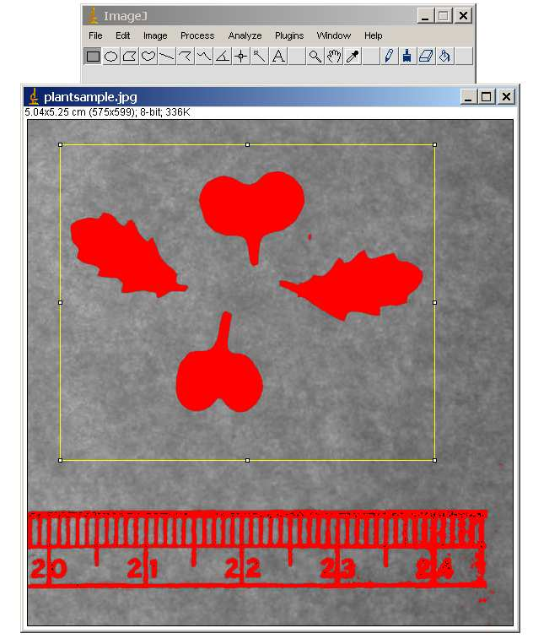

- Now go to the Analyze menu and click Set Measurements. Make sure the Area and the Limit to Threshold boxes are checked. This tells ImageJ to get the area of the red shape and just the red shape. The other boxes will take other measurements. The Min and Max Gray Value box will measure the minimum and maximum darkness of the selection. The mean box will show the mean darkness. None of these options matters for the calculation of area, so you can uncheck these.
- Then go to the Analyze menu again and select Measure. This gets the area of the selected leaves. Redraw the box around another set of leaves and make another measurement. Continue until all sets of leaves have been measured.
